PRESS RELEASE AUMÜLLER AUMATIC GmbH

Thierhaupten, 04/04/2023

Stand B1.118
Aumüller Aumatic at BAU 2023: Innovation creates added value
More power, more modularity, more flexibility

From the 17th to the 22nd of April, ventilation, smoke and heat extraction expert Aumüller Aumatic will be presenting numerous new products under its motto “Innovation creates added value” at BAU 2023, the world’s leading trade fair. The focus is not only on innovations, but also the added value they provide for architects, specialist planners, façade engineers, installers and users. “We listen to our customers carefully, take their problems away and replace them with solutions,” comments Alexander Birner, Head of Product Management.
More power: KS8 chain drive - stronger than all the others in its size category and particularly fast
No chain drive in its size category offers more performance. The Aumüller KS8 applies an impressive 800 N of force to the chain in a controlled manner to safely open and close even large-format facade elements. Despite its great power and compact dimensions, the KS8 achieves a speed of up to 22 mm per second, thus achieving 1,000 mm stroke including unlocking in 60 seconds. This saves cash, as a larger opening surface per window reduces the total number of windows required.
More modularity: Create custom drive solutions with the Aumüller Click system
The KS4 power supply unit and the KS4 locking drive are the two new highlights in the Aumüller Click family. The power supply unit is simply connected flush to the standard drive using the plug. In this way, every Click creates a 230 V KS4 drive. The pluggable KS4 lock drive grips the central lock of the window and ensures a secure seal. Both new developments have the same casing dimensions as the KS4 standard drive. Therefore, the system does not lose any of its aesthetic appeal, even as an individual combination. The Click system does not only get architects’ pulses racing, it also results in taking up less room in the installer’s warehouse. It is even possible to undertake simple adjustments to the drive system on the building site.
More flexibility: Ventilating with the Smart Vent Box

The retrofittable control modules simplify the creation and adjustment of ventilation solutions according to the user’s requirements. Thanks to their compact design, they fit into any standard flush-mounted box. The spring-loaded clamps allow wiring without
tightening a lot of screws. The automated learning takes place at the push of a button, without any additional programming steps. A test run for function tests is launched via the integrated ventilation button. The installation advantages and the resulting time savings create true added value for installers. For planners, the intelligent interface allows communication with modern building control systems, even after commissioning. This flexibility simplifies the planning process and saves money - the modules are only used where their functionality is really required.
The numerous innovations the Bavarian manufacturer is presenting at its trade stand are not products of chance. In fact, Aumüller Aumatic has established company-wide innovation management that recently received its seventh TOP 100 award in a row.
Approx. 3,200 characters incl. spaces

Further information:
www.aumueller-gmbh.de
Pictures:
Picture of KS8 chain drive
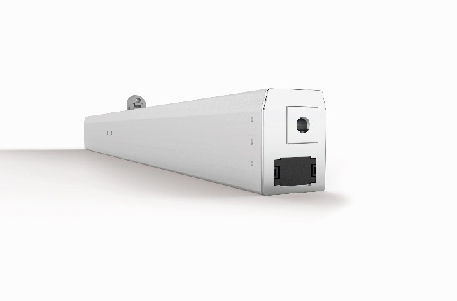
With 800N of power, the KS8 chain drive from Aumüller Aumatic opens and closes even large-sized facade elements at high speed.
Picture of Aumüller Click system:
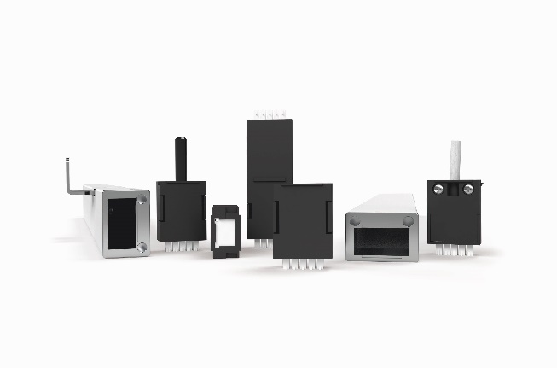
The pluggable click system from Aumüller Aumatic facilitates tool-free installation and configuration without the need for time-consuming connection and programming work.

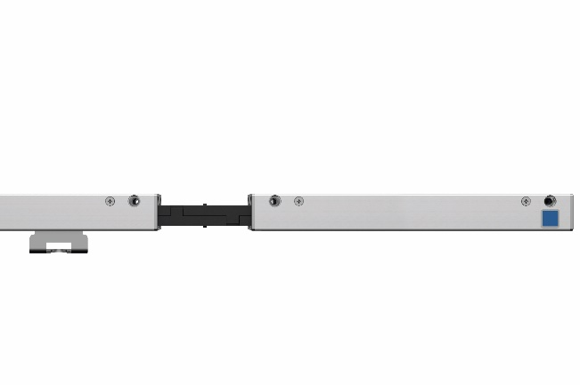
The KS4 power supply unit and the KS4 locking drive are the two new highlights in the Aumüller Click family.

Picture of Smart Vent Box SVB

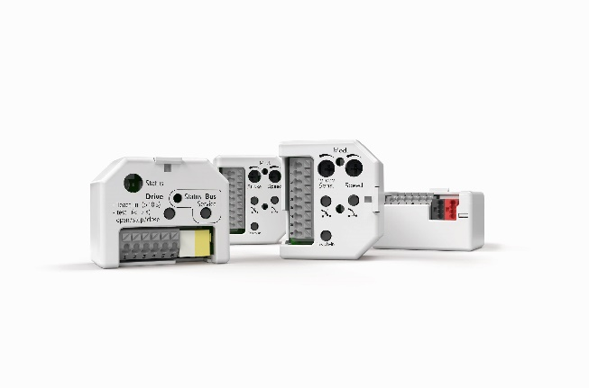
The retrofittable control modules of the Smart Vent Box simplify the creation of ventilation systems in several ways.

Pictures: Aumüller Aumatic

Usage rights: By crediting the source “Aumüller Aumatic”, the pictures can be used for an unlimited duration, free of charge for editorial purposes, exclusively in conjunction with the press release above.

Media contact:

AUMÜLLER AUMATIC GmbH
Gemeindewald 11
DE-86672 Thierhaupten, Germany
Tel. +49 (0) 8271 8185-0
Fax +49 (0)8271 8185-250
info@aumueller-gmbh.de
www.aumueller-gmbh.de

Danijela Popovic
Tel. +49 8271 8185-165
Fax +49 8271 8185-199
danijela.popovic@aumueller-gmbh.de

AUMÜLLER AUMATIC GmbH specialises in smoke and heat extraction systems and system solutions for controlled natural ventilation. As a renowned family business, AUMÜLLER AUMATIC combines 50 years of experience with a dynamic commitment for the benefit of its customers. With this know-how, the company offers a safe, energetically sustainable, easy-to-use and visually appealing automation solution for every window. AUMÜLLER products can be found worldwide in public and commercial objects - from stairwells to fascinating façades. As an internationally active company, AUMÜLLER is represented by further subsidiaries in China, Hungary, Poland and Russia, besides its headquarters in Thierhaupten. In the 2022 business year, AUMÜLLER AUMATIC GmbH employed approx. 180 employees worldwide.

